IDX G9 CHEMISTRY N STUDY GUIDE ISSUE 2
By Gavin Yu, Iris Lan, Isabella Wang
Chapter 4 Atomic Structure
Atom
- the smallest particle of an element that retains the chemical identity of that element.
Scanning electron microscope
- used to produce color-enhanced images of atoms
Democritus’s Atomic Philosophy
- all matter is made up of atoms
- Greek philosophers can only make some guesses by reasoning, debating, and discussion
  - not of evidence or proof.
Dalton’s Atomic Theory
- 1) All elements are composed of tiny indivisible particles called atoms.
- 2) Atoms of the same element are identical. The atoms of any element are different from those of any other element.
- 3) Atoms of different elements can physically mix or chemically combine in simple whole-number ratios to form compounds.
- 4) Chemical reactions occur when atoms are separated from each other, joined, or rearranged in different combinations. 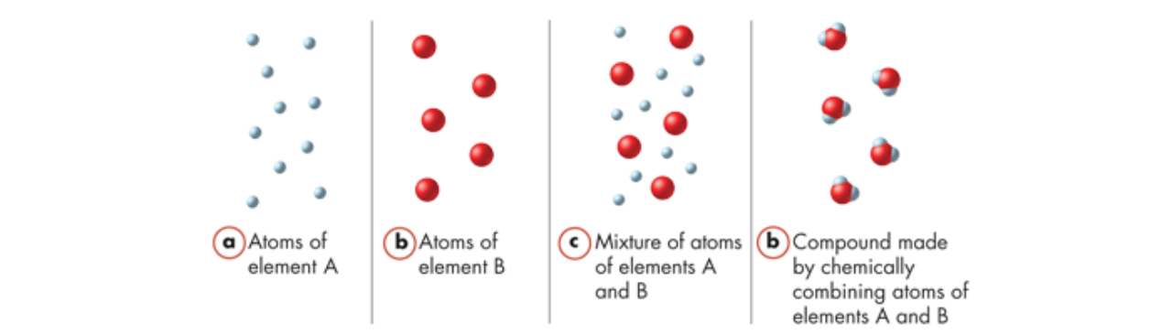

Dalton’s model of the atom

- A hard sphere that was the same throughout.
Subatomic particles
- Atoms are now known to be divisible.
- Three kinds of subatomic particles are electrons, protons, and neutrons.
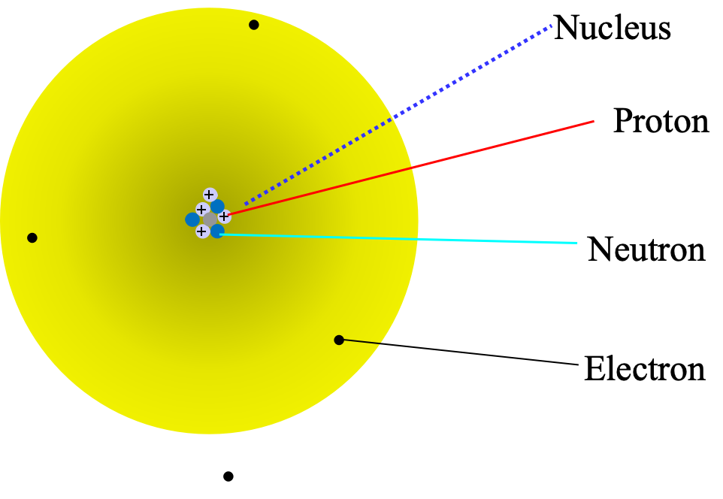
Electrons
- In 1897, the English physicist J.J. Thomson discovered the electron.
  - CRT (cathode ray tube) experiment
    - Cathode: negatively charged electrode
    - Anode: positively charged electrode
    - The result was a glowing beam, or cathode ray, that travelled from the cathode to the anode.

- Robert A. Millikan found the quantity of an electron’s charge.
  - the charge of an electron is 1.60 × 10^-19 coulomb
  - the mass of an electron is 9.11×10^-28 gram (Its mass is 1/1840 the mass of a hydrogen atom)
  - Millikan Oil Droplet
    - to find the quantity of an electron’s charge
    - measured how varying the voltage between the plates affected the rate of the fall
    - calculated the negative charge on the drops
    - Because the charge on any drop was always the integral multiple of 1.60ⅹ10^-19, Millikan deduced this value to be the charge of a single electron.
Thomson’s Model of Atom
- A sphere of positive charges with negative charges distributed evenly throughout the interior. 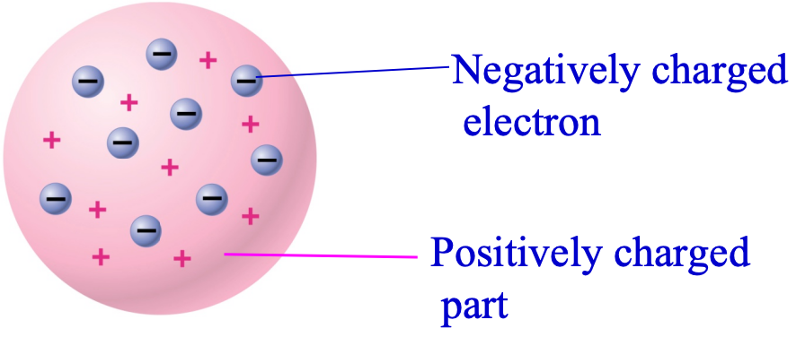
Rutherford’s Gold-foil Experiment
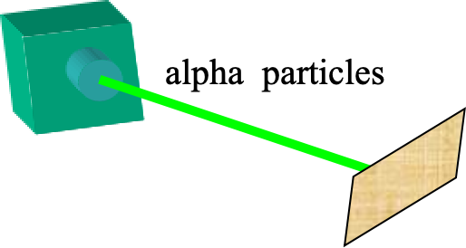
- They directed a narrow beam of alpha particles (nucleus of helium) at a fragile sheet of gold.
- Expected: alpha particles should pass through gold foil with little or no deflection.
- Actual result:
  - Most alpha particles went straight through or were slightly deflected.
  - A small fraction of the alpha particles bounced off the gold foil at very large angles.
  - Some even bounced straight back toward the source.
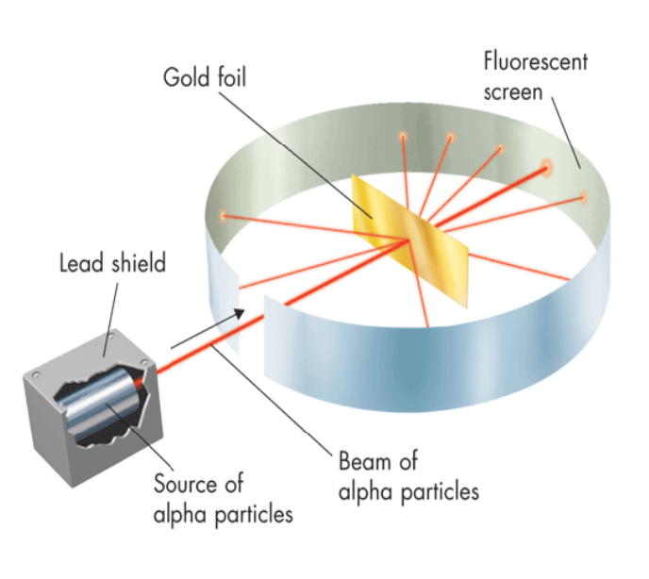

Rutherford’s Model of Atom
- All of an atom’s positive charge and most of its mass is concentrated in a very small core at the atom’s centre, which is called the nucleus.
- Also known as the model with a nucleus
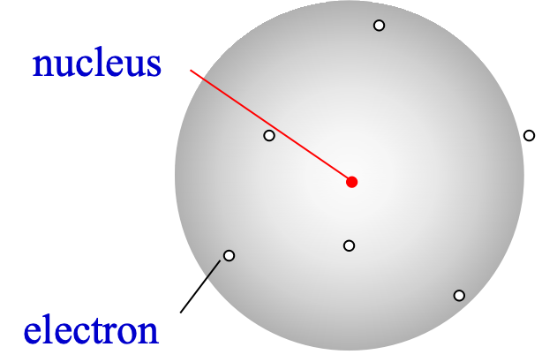
Protons
- The positively charged subatomic particles in the nucleus
Neutrons
- subatomic particles with no charge but with a mass nearly equal to that of a proto
Properties of Subatomic Particles
Particle | Symbol | Relative charge | Relative mass (mass of proton = 1) | Actual mass (g)
Electron | e– | 1– | 1/1840 | 9.11 × 10–28
Proton | p+ | 1+ | 1 | 1.67 × 10–24
Neutron | n0 | 0 | 1 | 1.67 × 10–24

Revised Model of Atom with Nucleus
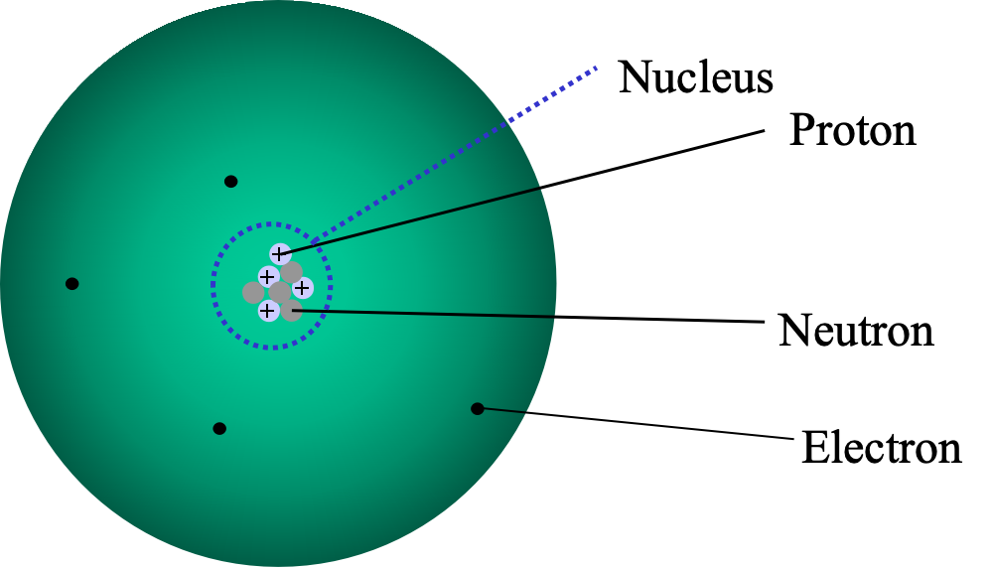
- For a neutral atom, the number of electron= The number of protons
Timeline:
- Democritus’s atomic philosophy
- Dalton’s atomic theory
- J.J.Thomson’s atomic theory
Found the existence of electrons by using CRT
Got an electron’s charge-to-mass ratio
- Rutherford’s atomic theory
Proved the existence of the nucleus
Propose the nuclear model
- Robert A. Millikan found the quantity of an electron’s charge.
- James Chadwick confirmed the existence of neutrons.

Atomic Number
- the number of protons in the nucleus of an atom of that element
- identifies an element
- For an individual atom which is electrically neutral, the number of electrons equals the number of protons
Mass Number
- n_{proton}+ n_{neutron}
Isotopes
- Atoms that have the same number of protons but different numbers of neutrons
- Elements are always found as a mixture with a fixed percentage of isotopes
- Isotopes of the same element have essentially identical chemical properties
- The major difference between isotopes is their mass
- Notation
  - Add a mass number after the element’s name
  - Place the atom’s mass number to the upper left of the element symbol
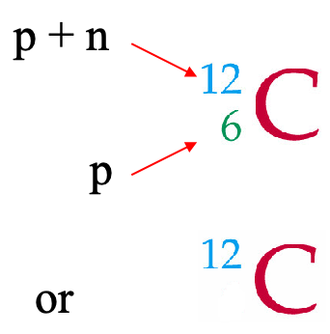
Ions
- When an atom loses or gains one or more electrons, it acquires a net electrical charge and is called an ion
- charge of ion = number of protons – number of electrons
- If an atom loses electrons, it becomes a positive ion
- If an atom gains electrons, it becomes a negative ion
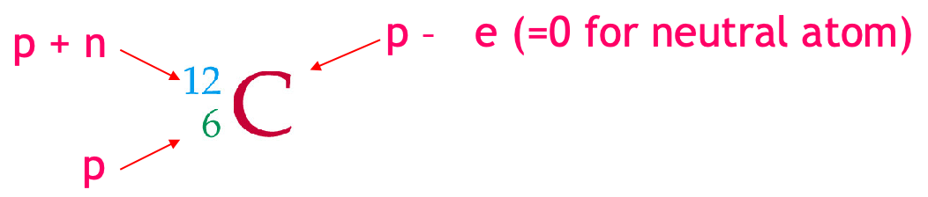
Atomic Mass
- Atomic mass is the average mass of its isotopes, considering the relative abundance of the isotopes.
- It is more useful to compare the relative masses of atoms using a reference isotope as a standard.
- The relative scale of atomic masses uses 1/12 of the mass of isotope C-12 as the standard.
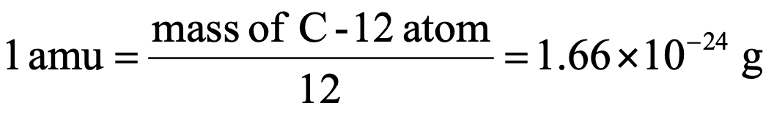
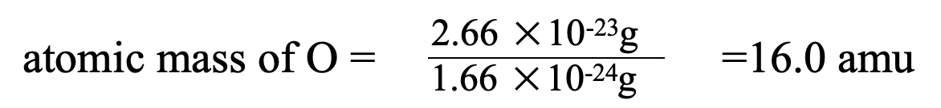
  - Use g, the number is too small, so we use amu for convenience
  - mass of a proton or a neutron ≈one amu
  - mass of an electron≈0
  - mass of an atom in amu ≈ proton No. + neutron No. (Mass no.)
- Atomic mass = ∑ mass of isotope× abundance
- The atomic mass of the element is close to the mass number of the isotope with high abundance
Abundance
- the natural prevalence of different isotopes of an element on earth

Chapter 5 Electrons in Atoms
Revising the Atomic Model
- All electromagnetic radiation travels at the same velocity: The speed of light (c) is 3.00 × 10⁸ m/s.
- c= λν
Planck’s Quantum Theory
- Energy can be either released or absorbed by atoms only in discrete “chunks” of some minimum size.
- Quantum
  - The smallest quantity of energy (E) that can be emitted or absorbed
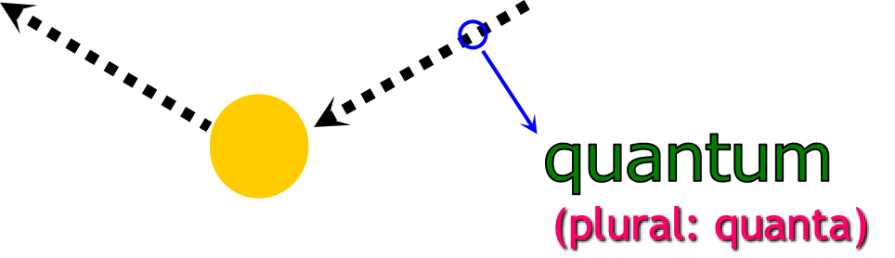
- E = hv
  - h is called Planck’s Constant = 6.626 x 10–34 J·s
- used by Einstein to explain the photoelectric effect
  - electrons are ejected when light shines on a metal.
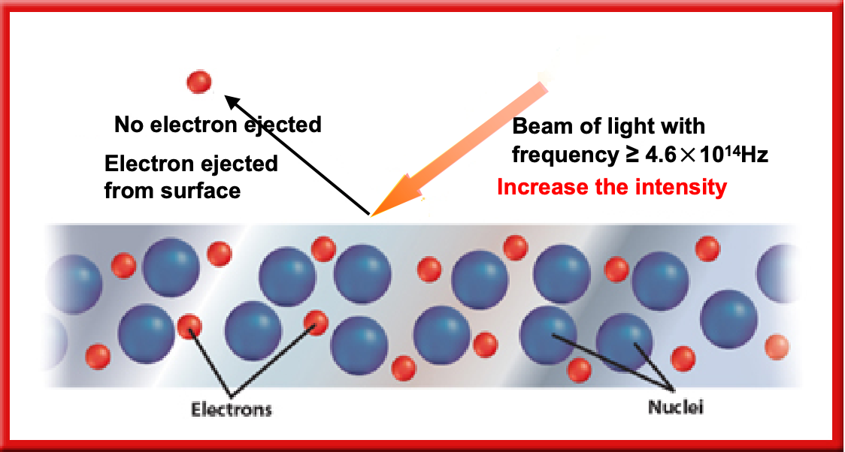
- Light consists of quanta of energy
  - behave like tiny particles, which he called photons
  - has energy given by Planck’s equation
- When a photon strikes the surface of a metal, it transfers its energy to an electron in a metal atom. (only when E photon≥ minimum, electrons can be emitted.)
Atomic Emission Spectra
- continuous spectrum
  - visible
  - One colour fades gradually into the next colour
  - 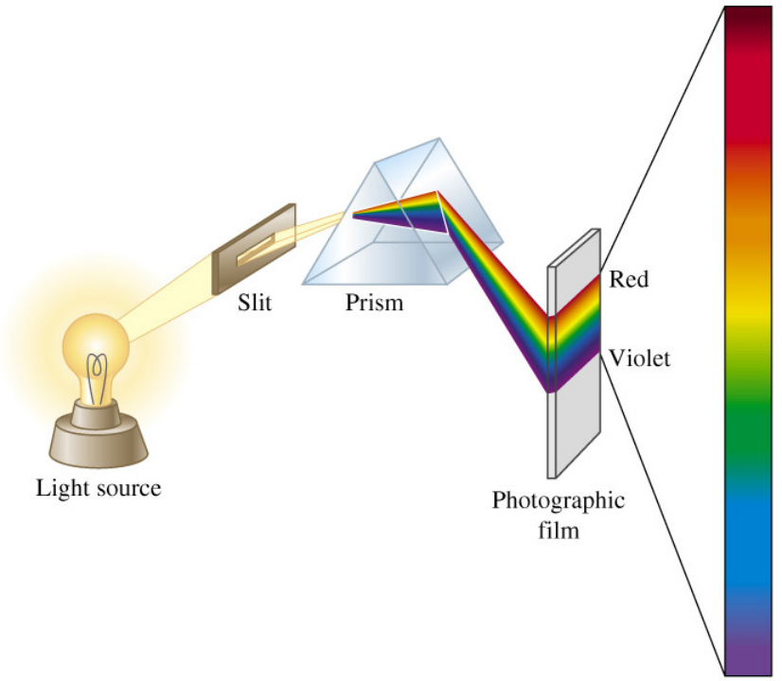
- visible spectrum
  - array of colours
- atomic emission spectrum
  - the set of frequencies (lights) of the electromagnetic waves emitted by atoms of the element
  - certain colours or wavelengths. (line spectrum)
The Bohr Model
- Electrons move in certain circular orbits with an allowed energy state around the nucleus designated by a quantum number n (n = 1,2,3,…).
- Energy is only absorbed or emitted in such a way as to move an electron from one “allowed” energy (quantised energy) state to another.
Explanation of hydrogen’s line spectrum
- Electrons can be excited to a higher energy level when they absorb energy. When electrons drop from a higher energy level to a lower energy level, certain frequencies of radiation can be emitted.
- ΔE=E higher-energy orbit – E lower-energy orbit = hv
- Evaluation
  - explaining single-electron atoms (hydrogen) and ions.
  - The introduction of quantised energy levels leads to the current model of electronic structure.
  - Electrons exist only in certain discrete energy levels.
  - Energy is involved in the transition of an electron from one level to another.
- Failed to
  - explain the spectrum of any other element
  - It can’t explain the different chemical behaviour of various elements.
  - Electrons don’t move around the nucleus in circular orbits.
Louis de Broglie (French, 1892-1987)
- Particles of matter should behave like waves and exhibit a wavelength, just as waves of light behave like particles of matter.
- The wavelike behaviour of particles is referred to as matter waves
The Heisenberg Uncertainty Principle
- The position and the velocity of a moving object cannot simultaneously be measured and known exactly.
- Inconsequential for macroscopic objects.
Quantum Mechanical Model
- Schrödinger (German, 1887-1961)
- The quantum mechanical model determines the allowed energies an electron can have and the probability of finding the electron in various locations around the nucleus of an atom
- electron cloud
  - The cloud is more dense where the probability of finding the electron is high.
  - 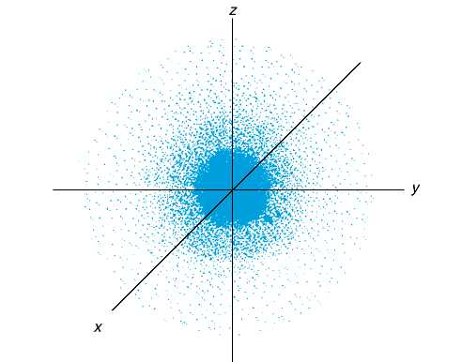
- atomic orbital
  - Solutions to the Schrödinger equation lead to this mathematical expression
  - represented pictorially as a region of space in which there is a high probability of finding an electron
  - Chemists define an orbital’s surface to contain 90% of the electron’s total probability distribution
  - Different atomic orbitals are denoted by letters s, p, d and f
  - 